**In Class Exercise Comparator**

Download these 3 files from Moodle.

* DVD.java
* DVDCollection.java
* TestDVDCollection.java

This is a simplified version of lab 5

You need to amend the program to sort the DVDs by title and also by name. The user can specify this at the keyboard – see sample output

Sample Output:

Enter your sort preference: Title or Cost

Cost

~~~~~~~~~~~~~~~~~~~~~~~~~~~~~~~~~~~~~~~~~~~

My DVD Collection

Number of DVDs: 4

Total cost: €112.75

Average cost: €28.19

DVD List:

Cost: €24.95

Title: Trainwreck

Director: Judd Apatow

~~~~~~~~~~~~~~~~~~~~~~~~~~

Cost: €25.95

Title: The Walk

Director: Robert Zemeckis

~~~~~~~~~~~~~~~~~~~~~~~~~~

Cost: €27.95

Title: No Escape

Director: John Erick Dowdle

~~~~~~~~~~~~~~~~~~~~~~~~~~

Cost: €33.90

Title: Paper Towns

Director: Jake Schreier

~~~~~~~~~~~~~~~~~~~~~~~~~~~~~~~~~~~~~~~~~~~~~~~~~~~~

Create a new class called DVDCostComparator

This class should implement the Comparator interface

Override the compare method as follows:

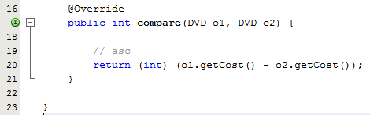

Create a new class called DVDTitleComparator

This class should implement the Comparator interface

Override the compare method as follows:

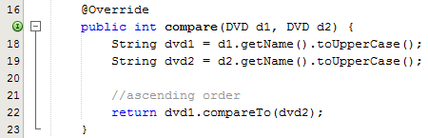

In the DVDCollection class you need to write a new method called sort as follows:

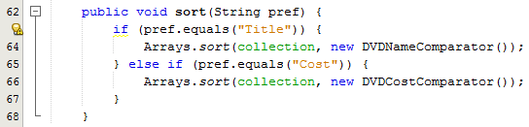

In the test class after the objects are created, you need to ask the user to enter their sort preference and then call the sort method:

